COMPETENCY BASED TRAINING PROGRAM
TOPIC 12
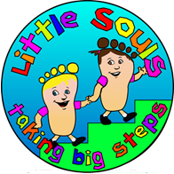
PICTORAL EXCHANGE COMMUNICATION SYSTEM (PECS)

little souls taking big steps
1 Allied Drive, Arundel
Gold Coast, 4214
(07) 5563 1490| www.littlesouls.com.au
2011

USING INFORMATION FROM
Sam, A., & AFIRM Team. (2016). Picture Exchange Communication System^{(R)}. Chapel Hill, NC: National Professional Development Center on Autism Spectrum Disorder, FPG Child Development Center, University of North Carolina. Retrieved from http://afirm.fpg.unc.edu/picture-exchange-communication-system

Pictoral Exchange Communication System (PECS)

TABLE OF CONTENTS
Subtitle Page

PECS Outline…………………………………………………………………………………………………………………..... 3
Terminology……………………………………………………………………………………………………………………… 4
PECS Drill Book…………………………………………………………………………………………………………………. 5
Handing Phase…………………………………………………………………………………………………………………. 6
Traveling Phase……………………………………………………………………………………………………………….. 8
Discrimination Phase……………………………………………………………………………………………………….. 10
Sentence Structure Phase………………………………………………………………………………………………… 13
Responding to “What do you want?”……………………………………………………………………………….14
General Commenting and Question Answering Phase…………………………………………………….. 15
PEC Resource Request……………………………………………………………………………………………………. 16
PEC Development…………………………………………………………………………………………………………….. 17

CBT OUTLINE
Topic 12- Pictoral Exchange Communication System (PECS)
Competency 12.1 Understands the 6 different phases of PECS
____ Criterion 12.1a: Knows the steps and mastery criteria for “Handing Phase”
____ Criterion 12.1b: Knows the steps and mastery criteria for “Traveling Phase”
____ Criterion 12.1c: Knows the steps and mastery criteria for “Discrimination Phase”
____ Criterion 12.1d: Knows the steps and mastery criteria for “Sentence Structure Phase”
____Criterion 12.1e: Knows the steps and mastery criteria for “Responding to “What do you want? Phase”
____ Criterion 12.1f: Knows the steps and mastery criteria for “General Commenting and Question Answering Phase”
____ Criterion 12.1g: Trainee can successfully implement correct phase with child
Competency 12.2: Can navigate the PECS drill book
____ Criterion 12.2a: Trainee can successfully answer questions using PECS Drill Book
Competency 12.3: Trainee knows how to request and develop PEC resources
____ Criterion 12.3a: Given a list of PECS trainee can successfully request the items to be made
____ Criterion 12.3b: When asked to make PECS staff can successfully develop resources.

TERMINOLOGY
Structured Environment- Where the staff is able to set up the necessary materials and present the items in a well-controlled manner
Unstructured environment- where the staff member does not have the ability to formally set up the exchange place for the child.
Generalisation- taking skills learned in one are with one set of materials and one staff member and doing it in a different environment with different materials or another staff member.
Field- the number of items the child is selecting from either on the table or on their PEC book
Discrimination (discriminates)- the ability to distinguish between two or more stimuli
0 Second Delay
Stimuli- the materials that are being presented or used for the child.
Most-to-least prompting- offering the child the highest level of support to complete the request and fading to the lowest level of support they need until they are independent. (refer to the prompting hierarchy for what is considered most and least)
THE PECS PROGRAMME DRILL BOOK
The PECS Drill Book is designed so that the therapist works with the child in the general order of the book, however; all children will come with different skills. The Director of Therapy will help decide which phase your child needs to start at in the monthly clinic meetings. As shown below, the child can start with Handing Pictures: Structure and Unstructured and work through to answering any question or making general comments. Each level has specific mastery criteria that needs to be met before moving to the next phase.
TARGET | INTRO | MASTER
Handing pictures: structured and unstructured
Moving around environment
Discrimination
Sentence Building
Responding to “What do you want?” or other questions.

Each section coordinates with a colour of paper for the colour it is printed in.
Numbers underlined and bolded in each phase are the pieces of the step that therapists will be taking data on.

Handing Phase
The handing phase is where therapists work with the child to hand a picture card that corresponds to the item the child wants. In this phase the expectations for the child are that they are able to look at the physical object in front of them, that they want, and hand the therapist the correct card to receive this item.

To identify which item the child wants the therapist can have a few items with corresponding PECS out on the table or floor and as the child reaches for an item the therapist immediately redirects that child to pick up the card and hand it to them. If a child requests an item more than 3 times or continues to ask for the same item each day this item can be considered a reinforcing item and should be recorded in the PECS Programme Drill Book. Once an item is considered a reinforcer then we can begin to present it in a single field to work on mastering the Handing Phase.

The Handing Phase will be taught in two different environments. A child must master each environment before moving to the next phase. The two environments are structured and unstructured.

STRUCUTRED ENVIRONEMT:
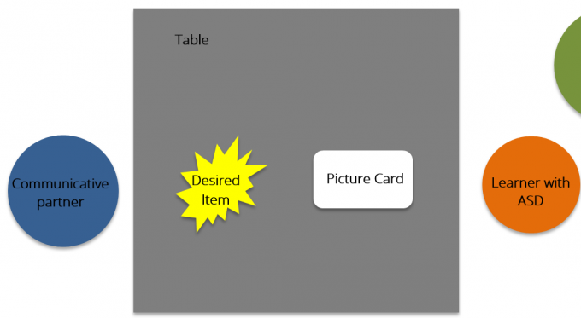
Above we see a general set up for a structured environment. The therapist and child are sitting at the table. For initial teaching, it may be easier for the therapist to sit directly beside the learner, but this will be something that each individual staff will decide what works best for them. The therapist has identified a reinforcing item and placed this item and the corresponding picture card on the table for the learner to select. As the child reaches for the item staff direct them to the card OR staff sit with their hand out so the child knows to hand the card. Reminder, placing your hand out is a form of a gesture prompt and will need to be faded to meet mastery criteria for this phase.

UNSTRUCTURED ENVIRONMENT:

This is ANY environment where you are not sitting at the table. Examples would be during downtime plays with your child, while in kindy room/yard or the preschool room/yard, or any other place around the center. Having a PECS folder to store your children’s PECS may be beneficial to ensure we are capturing every opportunity for them to practice using their PECS. When requesting an item at this phase ONLY ONE ITEM CARD should be in the front of the PECS book for the child to select, if you are using the PECS book to store your materials.

See corresponding video: Handing Phase for an example of structured and unstructured environments.

MASTERY CRITERIA:
A child has mastered this phase when they can:
- hand a picture card to their therapist with no prompting.
Traveling Phase
During this phase the learner works on 2 different movement phases. The first on is moving to their book to ask for an item with the therapist being close by. The second is the child moving to their therapist that is sitting further away from them and their PEC.

This phase is meant to teach the child that they will have to seek out their communication items and communication partner. This allows the skill to generalize outside of the one on one therapy setting.

MOVING TO THEIR PECS BOOK:
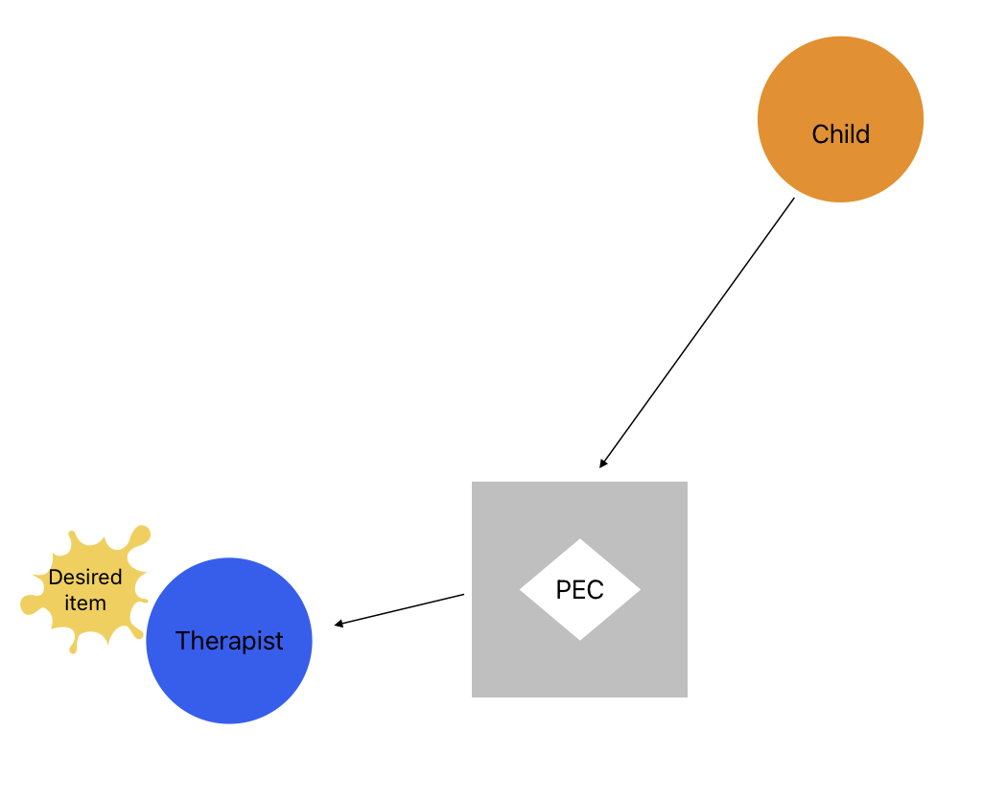
The therapist will be sitting beside the PECS folder and by the desired item (to block direct access if the child tries to grab it). The child will be away from the PECS folder and have to walk to the folder, pull of the card, and hand it to their therapist who is sitting close to the folder. The therapist then gives the child the item they requested.

MOVING TO THE THERAPIST (OR OTHER ADULT):
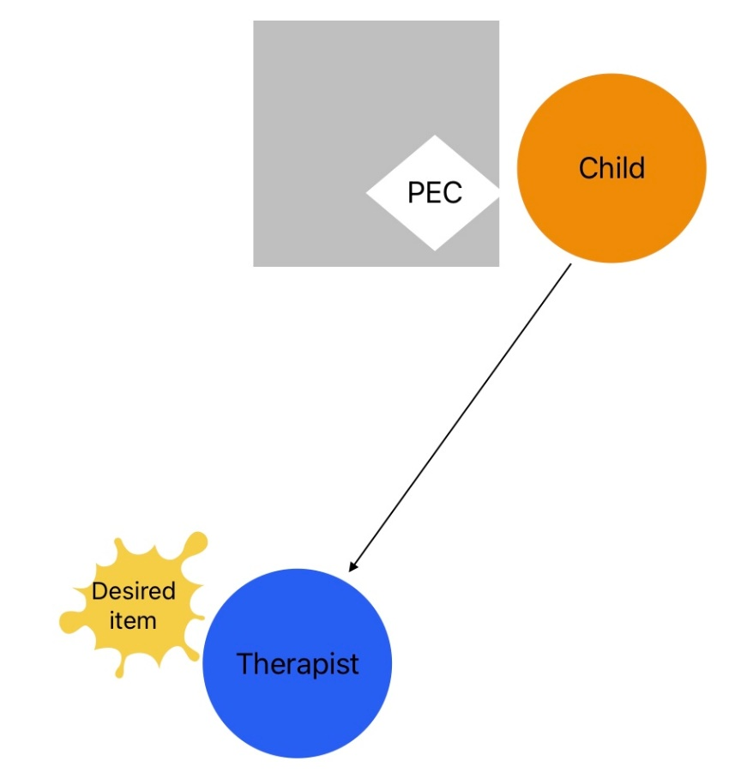
In this set up the child has their PECS book close by and the therapist will be sitting away from them. The child should get their PEC carry it over to their therapist and hand them the card to receive the item they want.
This is also a good time to start working on your child tapping your arm to gain your attention to speak.

See corresponding video: “Traveling Phase” for examples of the child engaging in both travel movements.

MASTERY CRITERIA:
A child has mastered this phase when they:
- will independently travel to their PEC book
- will independently travel to their therapist (or other adult) to request an item)
The child should have a list of 12 items or more. If this isn’t the case work during the next phase to increase their item selection of 12 or more.

Discrimination Phase
Once the child is able to hand cards to request one item, we want to begin increasing the number of items they select from. The Discrimination phase works first at presenting the child with two picture options. One of a preferred item and one of a non-preferred item. In our picture example “Oreo” is the preferred item and “puzzle piece” is the non-preferred item.

DISCRIMINTAION 2 CARDS: (PREFERRED & NON-PREFERRED)

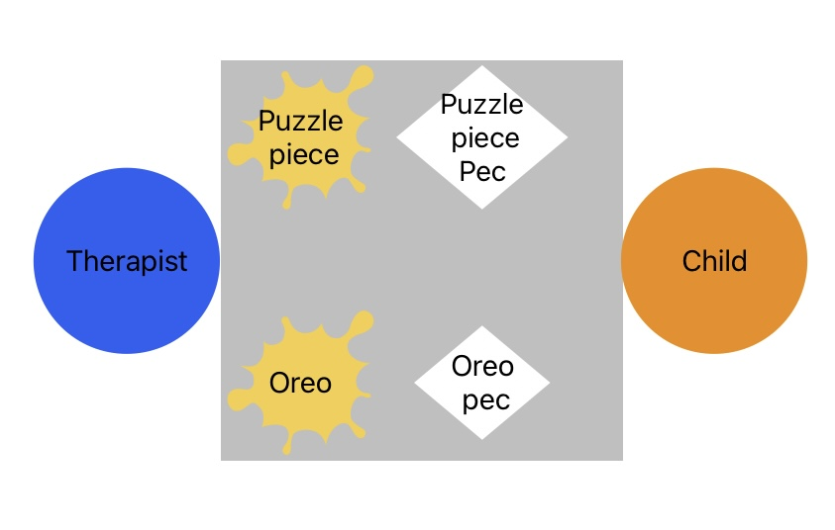
We start with the items on the table so the child can see what items are available. Once they can reliable hand you the preferred item we transition to have ONLY the PEC on the table/PEC Book.
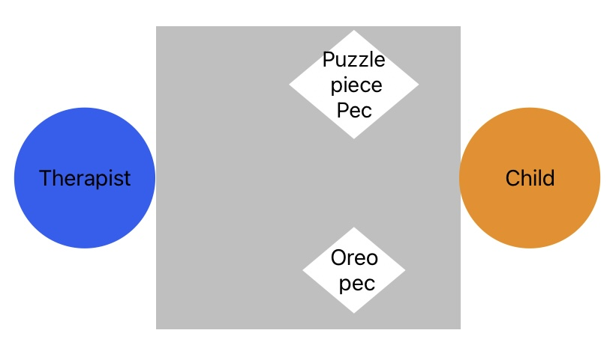

DISCRIMINATION OF 2 CARDS (BOTH PREFERRED ITEMS):
To teach this have two reinforcing items on the table and as the child starts to reach for an item present two preferred item PECS. They should hand you the item they were reaching for. If they had you the wrong one prompt them to hand you the correct one and the follow this with getting an independent response from the child.
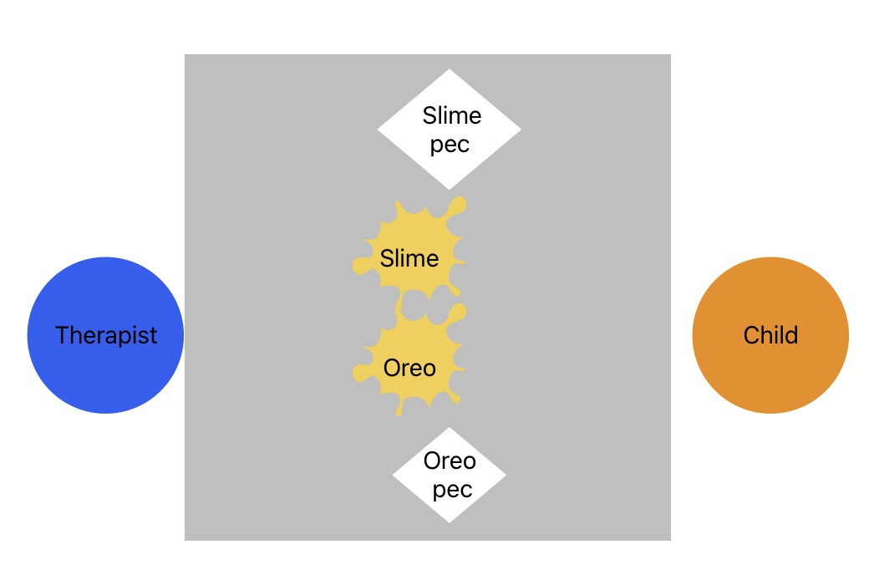
Work on fading the items on the table so your child only needs to reference the PEC card to choose what they want.
To test if the child is truly asking for what they want try a correspondence check. A correspondence check follows this structure:
- 2 (or more) preferred items on the front of the communication book
- Ask the learner what they want and take the card they chose
- Do not give them the item, rather present both available items.
- If the child chooses the item for the pec they gave you praise them and label the item and let them play with it
- If the child chooses another item, block access and prompt them to choose the correct item (ensuring you end on an independent correct).
Once they can distinguish between two cards add in a third reinforcer to increase the filed. Follow the same steps as you did with two preferred items. Once they have mastered 3 introduce a fourth one and follow the same steps. After four you should be able to continuously introduce new PECS without having to go through all the steps.

Some children will master this phase quickly and it might not be necessary to progress through each step and you will be able to increase the field quicker.
See corresponding video: “Phase Discrimination” for example of how to work on discrimination training with your child.
MASTERY CRITERIA:
To master this phase, the child should:
- Successfully discriminate between 12-20 PEC cards.
- Successfully discriminate in a field of at least 3 (ideally greater than 3)

Sentence Structure Phase
This phase we introduce both the “I want” PEC card and the sentence strip to the child’s PEC folder. To start the “I want” card will remain on the far left side of the child’s PEC book. The child will select the PEC card for the item they want and place it onto the sentence strip, pull the strip off of their book, tap their staffs arm and read the sentence by pointing to each card, and place everything back onto the book and pack away the PEC card they had selected.
When introducing this prompt the child where necessary using most to least prompting while they are learning and fade the prompts as soon as the child begins to respond independently.
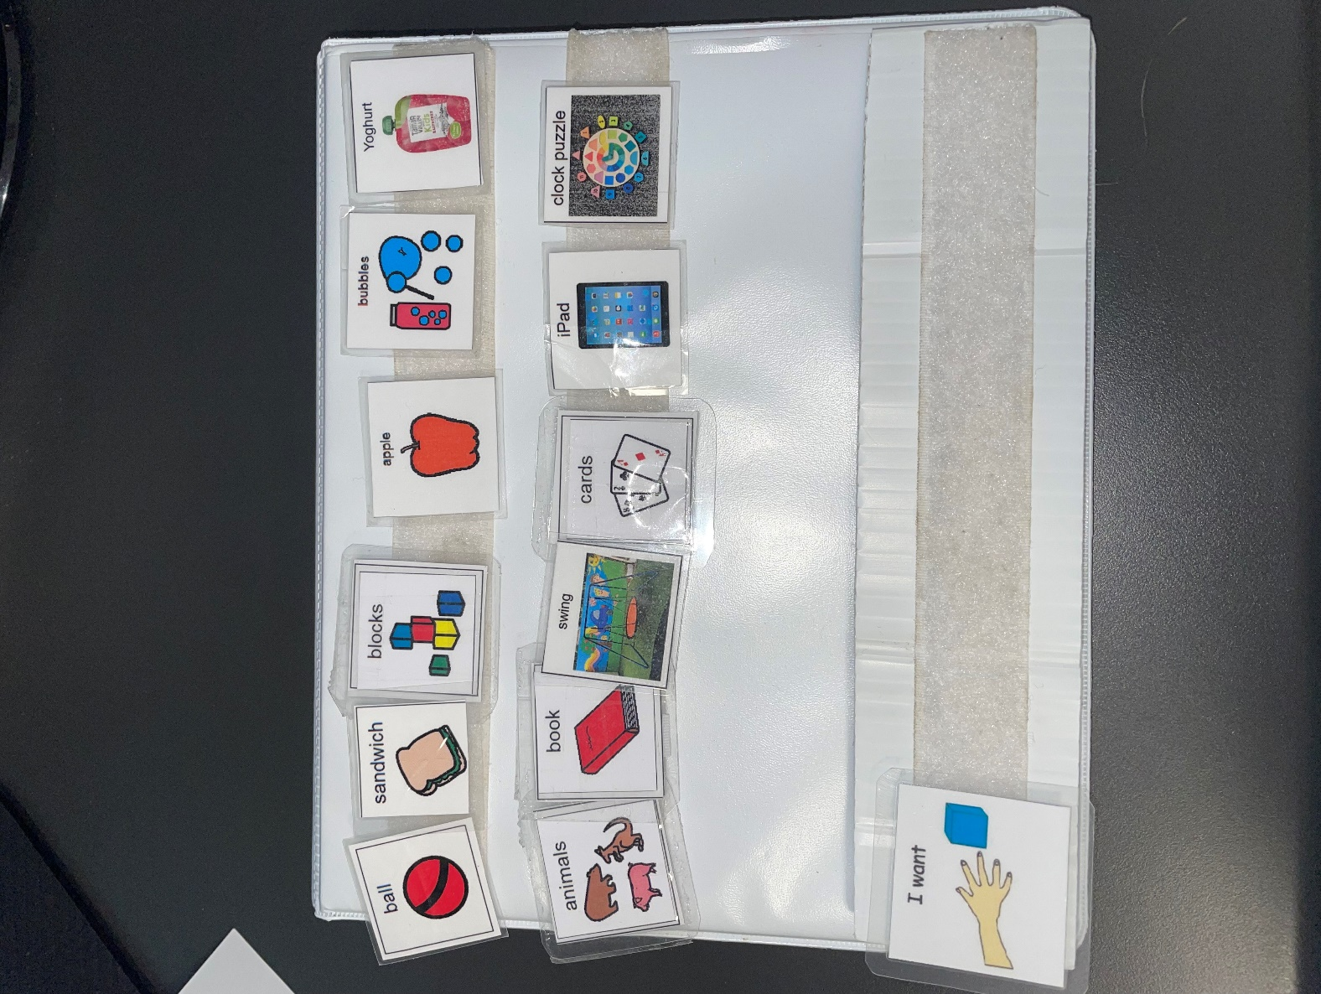
Staff should point to each card with the child and read out the sentence. Hearing the sentence constantly throughout their day will often lead to the child beginning to verbally repeat sounds/parts or/ whole words/the full sentence. When the child can consistently place the PEC card on their sentence strip begin to also remove the “I want” card during the pack away. The child will now be expected to form the full sentence on their PEC sentence strip.
Maintaining Previous Learned Skills:
Staff should ensure that the child is still able to meet the mastery criteria from the previous phases:
- Ensuring they are selecting the PEC picture for the item they want
- Traveling either to the book or to their therapist to request items
- Scanning from a field of 4 or more
See corresponding video: “Phase Sentence Structure” for examples on how to work on each skill in this phase
MASTERY CRITERIA:
To master this phase, the child should:
- They can independently place and pack away the “I want” PEC on their sentence strip, as well as any other PECS used to request.
- Tap their therapist for attention to speak
- Point to the sentence strip independently (if your child has started to vocalise any parts of the sentence strip it is expected that they begin to do this more consistently so we can prompt their vocal communication).
Responding to “What do you want?” Phase
In this phase a child should be able to respond to the question “What do you want?” with no prompting. From the first phase we have to asking the child what they want but providing prompts to signal that they need to be using some form of PEC to communicate to staff member. Now, the child should be able to ONLY hear what do you want and travel to their PEC book and make a request.

Once the child begins to respond well to “what do you want?” you can phrase the questions in different ways to work on generalisation of this skills. For example, you may ask:
- What do you want to play with?
- What would you like?
- What can I get you?
- Or any other way you can think to ask them.

See corresponding video: “Phase ‘What do you want?’” for an example of how a child will respond to being asked what they want.

MASTERY CRITERIA:
To master this phase, the child should:
- Be able to respond to ‘what do you want?’ with no prompts
General Commenting and Question Response Phase
This phase is not always reached by children due to different factors. However, if your child hasn’t begun to use vocal communication or needs the visual assistance this phase is used to work on responding to a variety of questions or making general comments throughout the day.
Occasionally the child may have a drill that uses PECS to label the colour of objects. For example, if you asked a child “what colour is a pig?” they could respond with “pig is pink” by having a ‘pig’, ‘pink, and ‘is’ PEC.
A child may be working on emotions and respond to the questions “how are you?” with their PECS book.
If by this stage they are still using PECS to communicate we want to create an environment where the child has the ability to spontaneously request / comment / to peers or staff.

See corresponding video: PECS & Play to see an example of how PECS can be used to comment and request items with peers.

MASTERY CRITERIA:
To master this phase, the child should be:
- Making spontaneous request independently
- Making spontaneous comments independently

PEC Resource Request
There is not always time available to request PECS needed for your child. If you need PECS resources, there are two things you should do.
- Check the staff bathroom cupboard closest to the wall for already made PEC icons
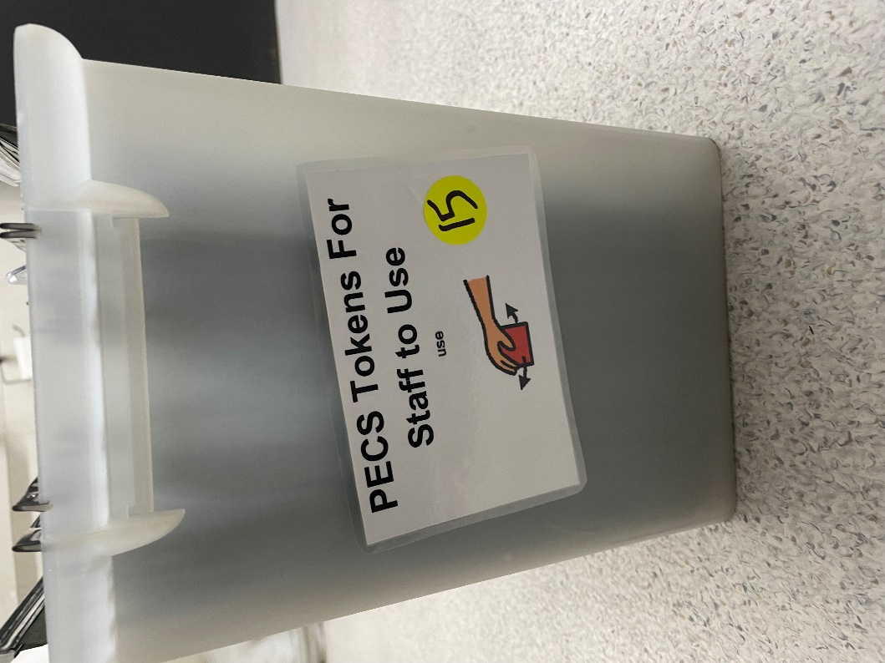
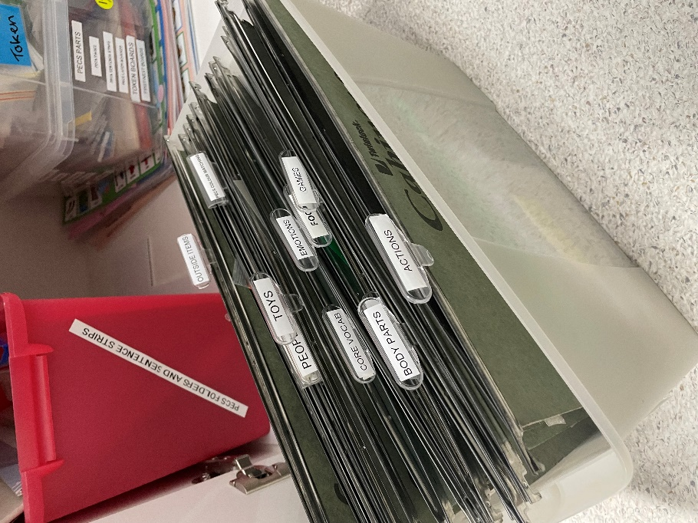
- If there is no icon, fill out the GREEN PEC resource log found in the staff room.
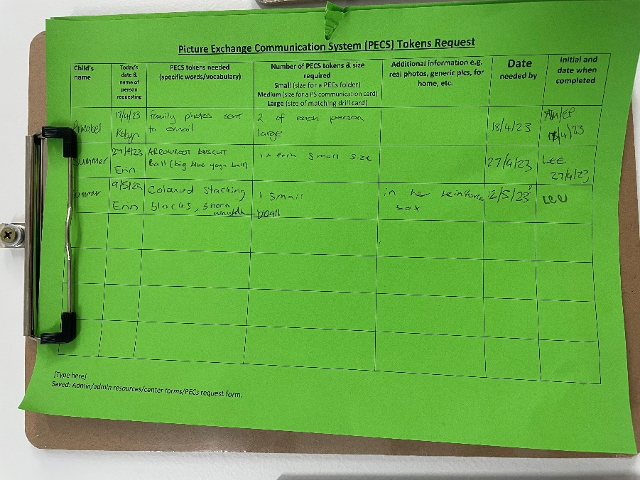
On the form write the child who needs the PECS, the date and your name, what PECS you need, the size you need, any additional information about the PECS, and the date its needed by.
PEC Development
If there is time or you are free you may be asked to make some PECS for you or other staff members. PEC development guide can be found on the side of the cupboard by the small computer desk in the resource room (it will also be attached to this CBT). The disk should be in one of the two computers in the resource room, if it is not check with Sue or Aileen as they may have it in the front office.

For pictures for the PECS it is best to try and use general pictures as this leads to easier generalisation for the child, however, sometimes we need very specific pictures. If you need specific pictures, then take a picture on any of the iPads and upload the photo to KindyHub and tag Facebook (don’t worry it will not post it to the Little Souls Facebook). Once the photo has been uploaded follow these steps:
- Log into kindy hub on the resource room computer.
- Select the picture you need.
- Download the photo.
- Save the photo under ABA-MEDIA-> PECS-> and the select the folder for your child (if your child doesn’t have a folder select one of the new folders and label it with your child’s code).
  - Children are coded for a number of reasons. The code is either B for boy of G for Girl and then the first two letters of the child’s name. If a child has the same name, then the first 3 letters are used OR the initial of their last name).
  - I.E. a girl named Emily would be Gem or a boy named Alex would be BAl.
- Once photos are saved follow the steps outlined in PEC instructions.
- Once the PECS are printed out, cut out each PEC so it is an individual square.
  - PECS need to be cut BEFORE laminating to ensure that the lamination can properly seal around the paper and the PEC will last longer.
- Once Pecs are cut out place them in a lamination sheet leaving some space between each pec for the lamination to seal and room to cut them out.
- Run the lamination sheet connected side first through the laminator.
  - Laminator takes a while to heat up so you may want to turn it on while your developing the PECS or when your cutting them out.
- Once the PECS go through the laminator cut the individual squares out again.
  - Round the corners of the pictures before placing them on the child’s PEC book. The corners can get very sharp and potentially hurt a child.
- Place a small piece of HARD Velcro on the back of the PEC and place it on the child’s PEC book OR give it to the staff member that requested it.
- If the resources are for someone else sign off the green PEC request log that you have completed the request.

